12 Chemistry : Dot Diagram Revision
Complete the table below.

Species | Structural formula (showing all valence electrons) | Draw shape (include all atoms) | Name shape
Iodate ion
IO₃⁻

Metasilicate ion SiO₃²⁻

Selenium disulfide SeS₂

Carbon monoxide
CO

Sulfur trioxide
SO₃

Sulfate ion
SO₄²⁻

Carbonate ion
CO₃²⁻

HCN

NH₄⁺

OH⁻

PO₄³⁻

C₂H₂

CO₂

CHCl₃

N₂

OCl₂

12 Chemistry : Dot Diagram Revision ANSWERS

Complete the table below.

Species | Structural formula (showing all valence electrons) | Draw shape (include all atoms) | Name shape
Iodate ion  IO₃⁻ | 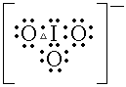 | 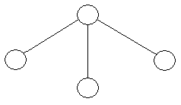 | Pyramidal
Metasilicate ion SiO₃²⁻ | 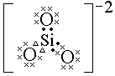 | 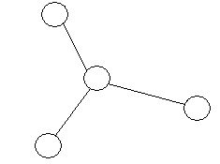 | Triangular planar
Selenium disulfide SeS₂ | 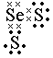 | 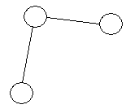 | Bent
Carbon monoxide  CO | 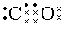 | 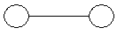 | Linear
Sulfur trioxide  SO₃ | 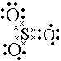 |  | Triangular planar
Sulfate ion  SO₄²⁻ | 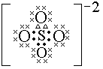 | 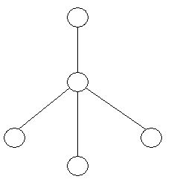 | Tetrahedral
Carbonate ion  CO₃²⁻ | 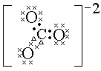 |  | Triangular planar
HCN |  | 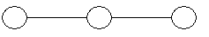 | Linear
NH₄⁺ | 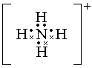 |  | Tetrahedral
OH⁻ | 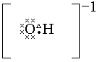 |  | Linear
PO₄³⁻ | 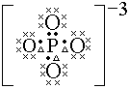 |  | Tetrahedral
C₂H₂ |  |  | Linear
CO₂ | 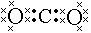 |  | Linear
CHCl₃ | 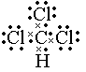 |  | Tetrahedral
N₂ |  |  | Linear
OCl₂ | 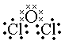 |  | V-shaped or bent

